**Assignment 1: Power BI Installation**

1.Installation Screenshot

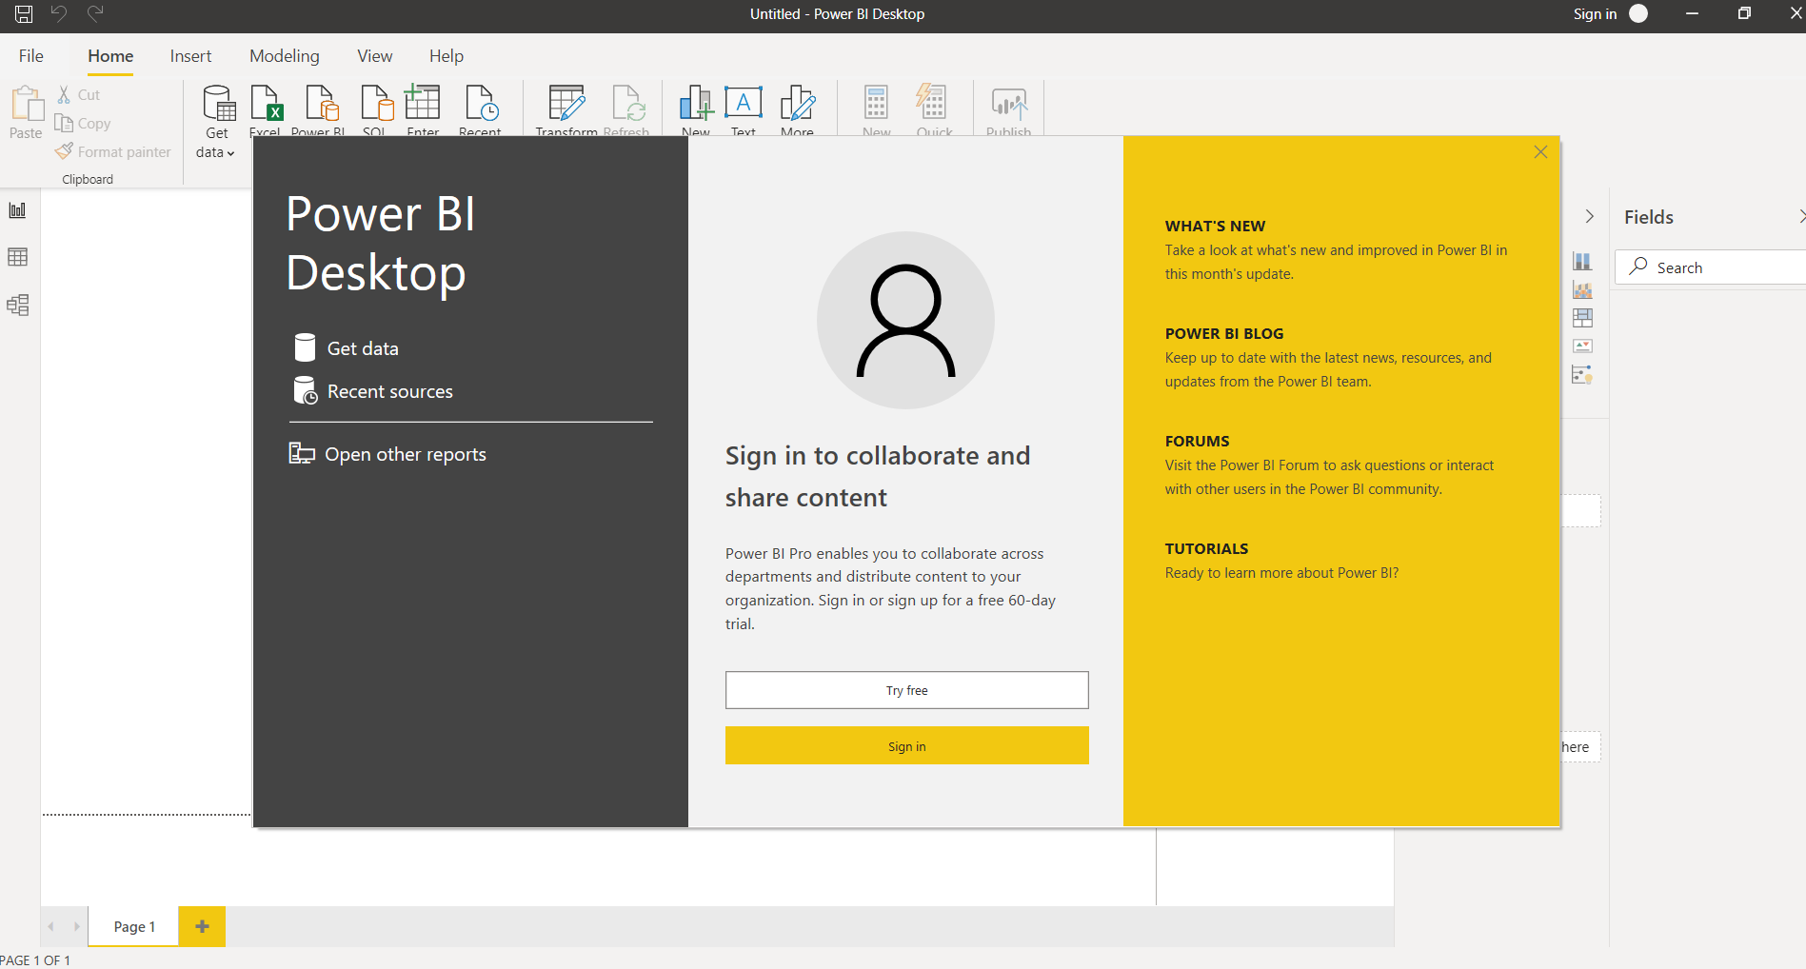

2a. Report View

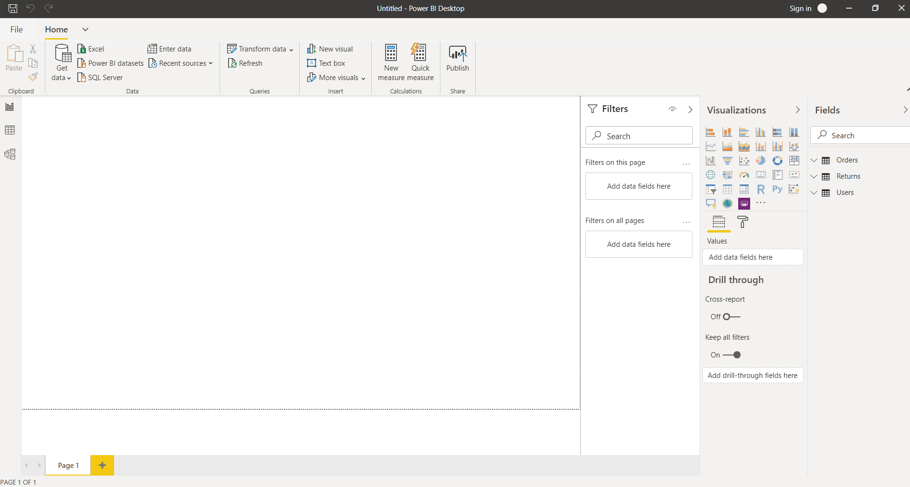

2b. Data View

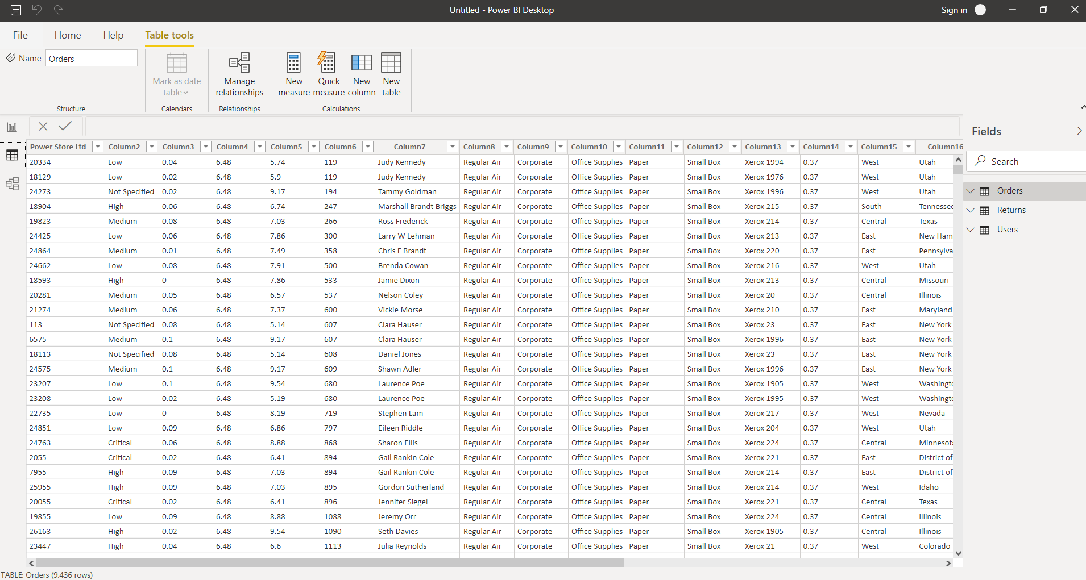

2c. Model view

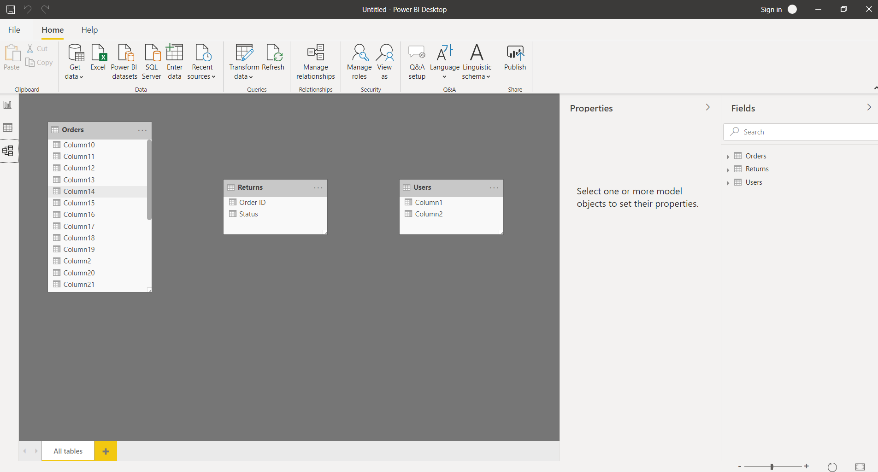

2d. Power Query Editor

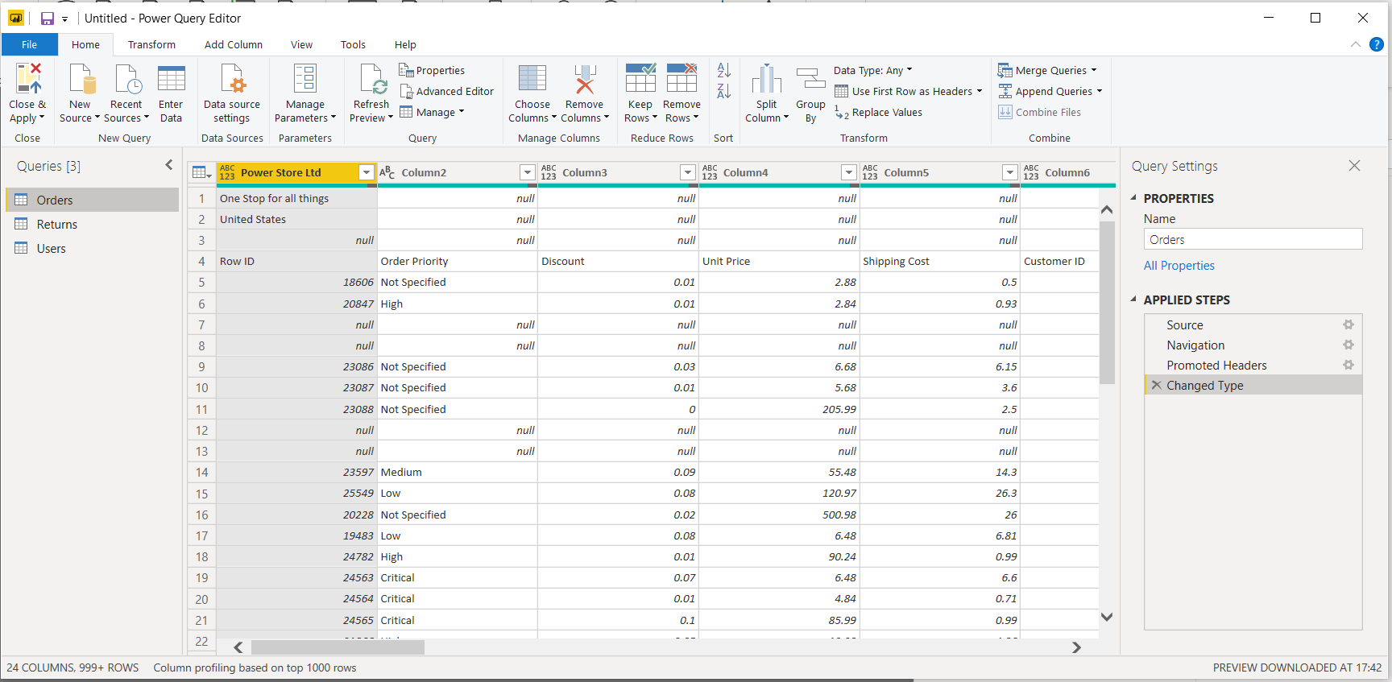

2e. Advanced Editor

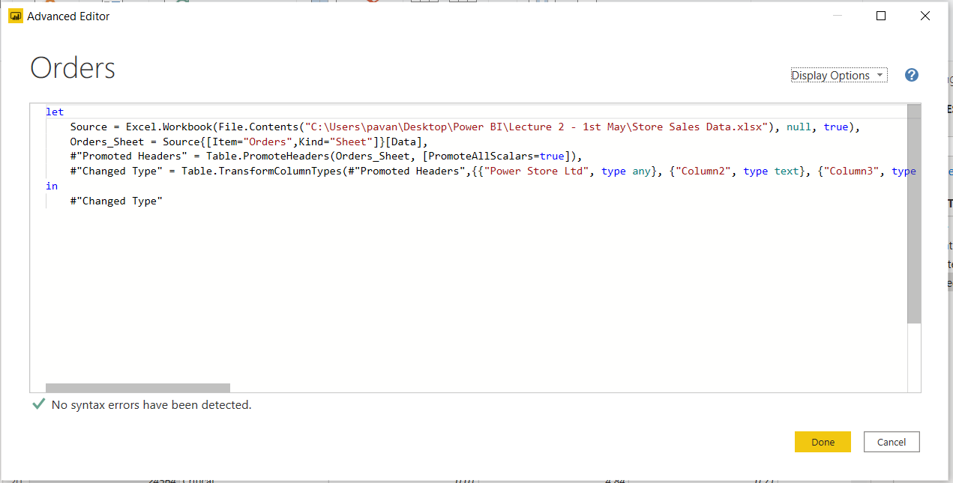

3a. Power BI Desktop

Application that can connect, transform and visualise the data. We can connect multiple data sources and make them into a data model. Some of the basic function include creating visuals,

report generation, dashboard creation, connect to different databases and also let you do performance analysis.

Power BI Desktop comes as a standard free software for personal use.

3b. Power BI Pro

It is self-service BI on the cloud for publishing, collaborating and sharing with licensing fee as:

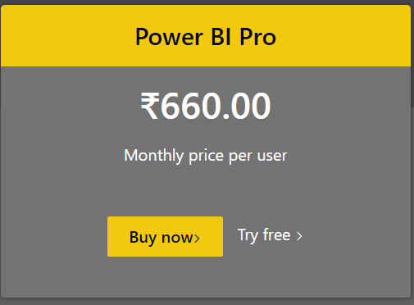

3c. Power BI Premium

It is enterprise level advanced analytics tool for on premises support and reporting. Used for big data analytics, on-premises report generation and deployment controls. License fee is:

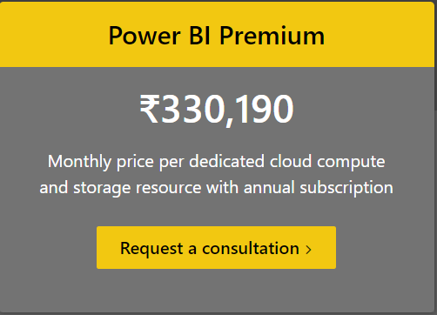

The feature comparison of Power BI: **PRO vs PREMIUM**

